1AC

Same as usual

2AC

CP

Only providing a working bureaucracy ensures long-term Trumpian governance. Current bureaucratic chaos undermines his agenda and success.
Bauer 8-29, Writer at the National Review. (Fred, August 29, 2025, “Trump cannot govern without the bureaucrats he despises,” UnHerd, https://unherd.com/newsroom/trump-cannot-govern-without-the-bureaucrats-he-despises/, Ulven)
A series of high-profile terminations — at the Federal Reserve, intelligence agencies, the Treasury Department and elsewhere — has sent Washington spinning. Fed governor Lisa Cook is now suing President Donald Trump over his “illegal attempt” to fire her, while the defenestration of the head of the Centers for Disease Control and Prevention — a Trump nominee who was confirmed only last month — has helped paralyse that organisation. While providing fodder for journalists, this frantic turnover also lays bare a bigger strategic imperative for the White House: to find some détente between a charismatic and a technocratic style of politics.
With his decades running the Trump Organization and dominating the tabloids, the President follows a personality-driven leadership style. Instead of being shackled by procedure, he opts to lead with his gut, viewing politics less as a clash of ideological visions and more as two or more power players striking a deal. He prefers bilateral negotiations to highly orchestrated summits for international affairs.
However, building the next paradigm almost certainly requires using, rather than simply detonating, bureaucracies. The US federal government is a globe-spanning leviathan, employing close to three million civilians and over two million in the armed services. Achieving any kind of major policy change demands phalanxes of nimble bureaucrats. Without those employees to formulate policy and enforce directives from the top, a chief executive will be left flailing. These bureaucracies provide the granular data crucial for helping policymakers understand the world in which they act.
Despite its scepticism of the expert class, the President’s populist realignment will require bureaucratic leverage to achieve any real success. For instance, a re-industrialisation programme would benefit from an encyclopaedic knowledge of supply chains — information that the federal government may not currently have. In public remarks earlier this summer, Vice President JD Vance lamented that federal experts could not tell him which products the United States was “completely reliant on some other entity” to manufacture. It will take at least a few Green Eyeshades to fill in those gaps.
The Trump administration’s global rebalancing ambitions make in-depth bureaucratic knowledge even more important. In face-to-face negotiations with world leaders, you need to know what cards each party is holding: how many missiles, fighter jets, and artillery shells. Certain key geopolitical variables cannot be reduced to a clash of personalities. For instance, a pivotal variable for the President’s deliberations about bombing Iranian nuclear facilities was whether those bombs would actually destroy those facilities. Those are technical — not charismatic — questions.
While some level of bureaucratic conflict might be an expected side effect of the President’s disruptive vision, too much chaos could actually undermine his agenda. Continuing melodrama at the Pentagon could, for instance, distract from his foreign policy reset. Also, sometimes bureaucrats can be politically useful early-warning mechanisms. Some DOGE-imposed changes to Social Security — such as cutting phone services for disability claims — generated ferocious bureaucratic pushback and were eventually withdrawn because of the intense popular opposition they generated. Likewise, the ongoing meltdown at the CDC suggests the grave political dangers of a sweeping move to limit childhood vaccinations. Such bans could easily alienate American families and split the Republican coalition.
The President’s second term, even more flamboyant and iconoclastic than the first, offers a good lesson in the importance of technical skill for a populist realignment. So far, Trump’s executive orders have had an outsized effect because he has located staffers who can dot the i’s and cross the t’s. For his biggest policy ambitions, he’ll need a bureaucracy — and he’ll need to know how to use it.

Productivity K

Policy focus is a floor not a ceiling—changes to labor laws improve material conditions, generate collective action, and empower workers
Galvin 21, associate professor in the Department of Political Science and a faculty fellow at the Institute for Policy Research, Northwestern University. (Daniel Galvin, 11-4-2021, “Alt-labor’s turn toward politics and public policy to combat the exploitation of low-wage workers,” Economic Policy Institute, https://www.epi.org/unequalpower/publications/alt-labors-turn-toward-politics-and-public-policy-to-combat-the-exploitation-of-low-wage-workers-building-power-and-punching-above-their-weight/)
Confronting low-road employers one at a time, however, can be very costly in terms of the resources expended and opportunity costs incurred. Because the labor violation has already occurred, workplace justice campaigns are inherently reactive—they do little to deter exploitation in the future—and once the campaign is over, the employer retains its outsized authority and may well continue to exploit workers. The same is true for filing complaints with state agencies and initiating lawsuits: Many organizers call them “band-aids” because they are reactive fixes rather than proactive deterrents. To be sure, direct actions, complaints, and lawsuits are all critically important tools in the fight against worker exploitation—especially when used as leverage in combination with one another—but they often drain worker organizations of precious resources without making much of a dent in the underlying power imbalance in the workplace.
This, more than any other reason, is why alt-labor groups have increasingly turned to public policy—to state laws, local ordinances, and other uses of public authority—to combat workplace exploitation and strengthen workers’ rights. Like workplace justice campaigns, policy campaigns serve as rallying points for generating collective action, building solidarity, and empowering workers.12 But unlike workplace justice campaigns, public policies have the potential to raise the floor on labor standards across thousands of workplaces and entire geographic regions in one fell swoop. “That’s how we scale up our efforts,” explained Adam Kader, policy director and former longtime worker center director at Arise Chicago. “Our path to scale is via policy. We go over the heads of all these employers. Then, theoretically, we’ve changed every workplace in the entire region.” If properly designed and executed—e.g., with strong penalties and vigorous enforcement—employment laws can reduce the incidence of labor standards noncompliance (Galvin 2016). When low-road employers nevertheless continue to violate the law, policies provide mechanisms through which workers can petition the state to hold employers accountable.
Alt-labor organizers often describe public policy as an alternative way to recreate, one policy at a time, the semblance of a collective bargaining agreement that is enforced by the state. “We are trying to fill the holes of what a collective bargaining agreement can get workers, for the workers who don’t have a collective bargaining agreement,” Deborah Axt, former co-executive director of Make the Road New York (MRNY), told Jane McAlevey (2014, 185). “For the many workers in the informal economy, we are trying to put as many pieces together as we can to offer protections as if they had a contract.” But Axt and other organizers also understand fully the limitations of employment law. They tend to view it as a last resort in the context of declining unions and widespread exploitation of low-wage workers—a workaround solution to raise the floor on labor standards and recover some workers’ rights.
At their most aspirational—when asked to sketch their boldest vision for the future—many organizers paint a similar picture: Each new policy win contributes in a piecemeal way to building a different kind of state, one that views the employment relationship from the perspective of workers at least as much as from the perspective of employers and business owners, one whose operations are geared toward protecting workers’ rights and raising the floor on labor standards at least as much as toward promoting economic growth. Ideally, this reconstituted state regulatory apparatus will work hand-in-glove with a reformed national labor law and revived unions, with each helping to fortify the other (Block and Sachs 2020; Fisk 2020).
The rough outlines of this vision are, in fact, starting to appear in select urban locations. Consider the growing complement of pro-worker policy enactments that have accumulated over the last 10 years in Chicago, Cook County, and across Illinois. Alt-labor groups, in coalition with labor unions and others, have been instrumental in persuading city, county, and state lawmakers to enact multiple minimum wage increases, anti-wage-theft and wage protection laws, earned paid sick leave, fair workweek advance scheduling requirements, a temp workers’ bill-of-rights law, a domestic workers’ bill-of-rights law, an anti-retaliation ordinance, and whistleblower protection for workers who report discrimination and harassment. They have also created new state enforcement capacities via the new Office of Labor Standards in Chicago (founded in 2019) and the Workplace Rights Bureau in the Illinois attorney general’s office (founded in 2015), both of which are empowered to investigate employers and enforce the new employment laws. Chicago-area worker organizations view these accomplishments as only the beginning (e.g., Doussard and Lesniewski 2017; Oswalt and Rosado Marzán 2018).
But “deep blue” Chicago, where alt-labor groups work in solidarity with traditional labor unions and other powerful groups and where almost all elected officials are Democrats, is not the only city where alt-labor groups have made headway in recent years. As noted above, between 2003 and 2019 alt-labor groups were cited by local newspapers as leading advocates in 73% of all minimum wage, paid sick leave, and fair workweek laws enacted in 93 cities and counties throughout the United States (see Appendix Table 2 for detailed list). Alt-labor groups were hardly solely responsible for getting these laws passed, nor would any claim to be; as indicated in the appendix, they almost always worked in coalition with unions and other community-based groups. But they were high-frequency repeat players: While dozens of other types of advocacy groups were instrumental in particular times and places, only alt-labor and traditional labor groups were consistently on the front lines.13 A similar pattern can be observed in subnational anti-wage-theft policies. Doussard and Gamal (2015) found a strong and statistically significant relationship between the number of worker centers in a state and the introduction of 255 state-level anti-wage-theft laws in 2004–2012; Galvin (2016) similarly found that most of the 12 major wage-theft laws passed between 2006 and 2013 were the result of vigorous advocacy by worker centers and allied groups.

Unions are a necessary component in anti-imperial alliances
Brand and Wissen 21, *Professor of International Politics at the University of Vienna, **Professor of Social Sciences at the Berlin School of Economics and Law (Ulrich* and Markus**, 8-30-2021, “Workers, Trade Unions, and the Imperial Mode of Living: Labour Environmentalism from the Perspective of Hegemony Theory,” [ch. 30] pp. 699-720 in The Palgrave Handbook of International Labour Studies, Cham: Springer International Publishing) AFA+
Secondly, labour and the environment can be linked in a strategic manner. This is the case where unions enter into alliances with environmental organisations in order to enhance their social power, or, in the words of HansJürgen Urban, member of the board of the German metalworkers’ union IG Metall, ‘to complement individual power resources through cooperation with other movements, initiatives and organisations’ (Urban 2018, 347, our translation). The aim may be to foster green job creation and green infrastructure provision or, more ambitious, to develop ‘a new culture of mosaic-leftist alliances […] ultimately with the intention to transform the system’ (ibid., 347). Examples include the BlueGreen Alliance in the United States (Stevis 2018, 458–460), the rapprochement between Austrian unions and environmental organisations which, on the side of the unions, has been triggered both by the growing acknowledgement of an energy transition and ‘the need to build strong alliances with other progressive forces in society to counteract the neoliberal shift in general, particularly in energy policy’ (Soder et al. 2018, 526), and the cooperation between IG Metall and the environmental NGO German Nature Conservation Ring in the early 1990s, which resulted in a programmatic document on the socio-ecological transformation of the transport system (IG Metall and Deutscher Naturschutzring 1992).12
A strategic connection between labour and the environment may increase the social power of progressive forces in their respective fields through alliances that allow for a common politicisation of issues related to wage labour and ecology. This is important because it can result in concrete improvements that should not be underestimated (see ILO 2018 and Galgóczi 2019 for several examples). Yet, there is a danger that these improvements will not extend beyond an ecological modernisation of the imperial mode of living. This is where a third way of linking labour and the environment comes into play. It is about an organic connection which re-establishes the constitutive relationship between labour and nature torn apart by the capitalist mode of production. In contrast to the instrumental view on labour and the environment, the organic concept considers the climate crisis rather than climate policy as the principal threat for workers and their communities. Like the strategic approach, it draws on strong alliances between unions and environmental organisations, but places more emphasis on developing a common agenda for a fundamental socio-ecological transformation than on mutually supporting particular organisational interests. Without doubt, the latter, and with them the workplace-related ‘economic’ functions of unions, remain crucial. However, they are formulated in a way that they form part of a comprehensive strategy of systemic change.
The organic link between labour and the environment stands in the tradition of social movement unionism (Moody 1997). Starting from the experience of unions in the Global South that have successfully transcended the separation between narrower ‘economic’ and wider ‘political’ struggles, social movement unionism has confronted Northern unions with the challenge ‘to reinvent themselves as social movements, not only responsible for the working conditions of their members, but for their general living conditions as well’ (Räthzel and Uzzell 2011, 1221). It has, however, been rather silent on ecological issues—a void that has been filled by more recent contributions. Thus, Ashley (2018) describes the South African Million Climate Jobs Campaign, which was formed in 2011 by activists from trade unions, social movements, non-governmental organisations, and academics, as an attempt to combine the creation of decent work with the protection of the environment and the provision of communities with essential infrastructure (see also Satgar 2015 on the climate justice approach of the South African metalworkers’ union NUMSA, see Sikwebu and Aroun, Chap. 3, Pillay, Chap. 4, Cock, Chap. 8)
Cha and Skinner, together with a working group composed by unionists, have developed an ambitious climate jobs agenda for New York state that aims ‘to simultaneously reduce greenhouse gas emissions and reverse inequality by protecting workers and creating good, family-sustaining jobs’ in the building, energy, and transportation sector (Cha and Skinner 2017, 3; see also McAlevey 2019). In addition, Felli (2014, 389–391) analyses the climate change-related activities of the International Transport Workers’ Federation (ITF) as a paradigmatic example for a socialist strategy of addressing the ecological crisis, centred around an ecologically transformed and democratically controlled mobility system.
A common goal of the authors arguing for an organic connection between labour and environment is to rethink labour and the whole economy from the point of view of social reproduction, that is, to raise the questions of ‘what, how and how much to produce’ and to demand ‘that these questions be answered through mechanisms other than that of price—that is, by nonmarket institutions’ (Felli 2014, 391). This is an issue, first, of rethinking and reorganising the economy from the perspective of what is socially useful and necessary; second, of reshaping the society-nature relationship in a way that takes the reproductive necessities of human and non-human nature into account; third, of redefining work in a comprehensive way that does include not only wage labour but also care, political work, and individual development; and, fourth, of equally redistributing the four dimensions of work between women and men (Haug 2009; Littig 2018). It is against this background that, as Jacklyn Cock (2018, 216) has argued, ‘a social reproduction approach can potentially validate and link separate struggles’.
For unions this means that they, rather than striving mainly for a redistribution of the wealth which is produced within a socio-ecologically destructive economic system, attack the very form of wealth production and place emphasis on the satisfaction of human needs in a socio-ecological sustainable manner, in other words, on the ‘foundational economy’ of care and life-supporting infrastructure systems (cf. Foundational Economy Collective 2018). This is not an easy undertaking, since it requires learning processes and organisational efforts that go far beyond those already organised in unions. And the more industries are concerned whose future is questionable on ecological grounds, the more difficult it becomes. Thus, the Corona pandemic, through reinforcing the structural crisis in key sectors like car manufacturing, has given rise to traditional positions within unions which conceive the labour-environment relationship in a merely instrumental way. Like in the crisis of 2008–2009, officials of the German metalworkers’ union, in concert with business representatives, for example, call for the state to stimulate the demand for ecologically modernised cars. The idea of a comprehensive transformation of the car-centred transport system here is sacrificed to a certain extent for a supposed job security of the union’s core membership.
Without denying the dilemma trade unionists are confronted with, this is a narrow and short-sighted strategy which, while aiming at protecting workers against crisis policy, deepens the crisis itself and enhances workers’ vulnerability in the long run (cf. Ashley 2018, 290). It is, however, contested in the union itself: months before the outbreak of the Covid-19, Katharina Grabietz and Kerstin Klein, two secretaries of the IG Metall, emphasised that workers in car manufacturing are ‘not solely employees of a climate-damaging industry, they also live in cities without clean air and have children who take to the streets on Friday fighting for their right to a liveable planet. […] The discussion about transformation and decarbonisation is linked to fundamental questions of how we want to live, produce and do the economy’ (Grabietz and Klein 2019, 37, our translation).13 The two authors demand a democratic discourse about the transformation of production on the level of the firm, the branch, and society at large. ‘This discourse must be explicitly critical of capitalism, if it shall not merely fight symptoms but strive for abolishing the systemic causes of job losses and environmental destruction’ (ibid., 37).
The Covid-19 crisis will probably serve as a catalyst for reshaping the labour-environment relationship. Without doubt, there are strong forces fostering a socio-ecological roll-back, both within and outside the unions. However, there is also much evidence that unions have a lot to win from organically linking labour and environment from the perspective of social reproduction. Public ownership and democratic control of the means of production and subsistence are important preconditions. Reclaiming them and searching for the respective social and international alliances will be crucial for overcoming the imperial mode of living in favour of a good life for all.

Alliances between disability activism and labor are necessary to combat cuts to necessary services.
Bagenstos 17, Professor of Law at Michigan, former general counsel of the United States Department of Health and Human Service, (Samuel, “Disability Rights and Labor: Is This Conflict Really Necessary?” Indiana Law Journal, Vol 92, no. 1 (2017), pp. 277-298, https://repository.law.umich.edu/cgi/viewcontent.cgi?article=2851&context=articles) rose
But there is more to the pragmatic argument than just policy wonkism. As some of my discussion to this point suggests, the political landscape facing disability rights advocates these days is a particularly challenging one. As the disability rights movement has recognized that public services, along with civil rights, are crucial to promoting integration and empowerment for people with disabilities, it has repeatedly confronted the incredibly harsh budget politics of our current era. We live in an era of austerity, particularly at the state level.96 Medicaid, which finances personal-assistance services for disabled persons, is one of those entitlement programs, and it is perpetually threatened by cuts at the state and federal level. Indeed, the political pressures on Medicaid have only increased with the adoption of the Affordable Care Act97—which dramatically expanded the program—and the Supreme Court’s National Federation of Independent Business decision98—which made the expansion optional for each state.99 Many states with Republican-controlled legislatures refused to participate in the expansion, and the entire controversy high- lighted the political pressures on the Medicaid program as a whole.100
In a world like this, disability rights advocates need allies. And unions can be important allies in the effort to defend and enhance spending on programs like Medicaid. When disability rights advocates defend the rights of workers in Medicaid programs, that cements an alliance with the representatives of those workers to defend and expand those programs. In the end, the answer to the problem of limited resources is not for disability rights activists and labor to fight increasingly pitched battles over allocation of a smaller and smaller pie. The only answer is to engage in political activism that will increase the resources that the state devotes to community- based services for people with disabilities. Increased resources will promote the independence and full citizenship of disabled Americans at the same time it provides stable and well-paying jobs for personal-assistance workers. And the only way to engage in successful advocacy on this front is for people with disabilities and the labor movement—the interests that gain the most from expanded investments—to work together.

Incremental reform is good---rejecting it is ivory tower logic.
Delgado 9 (Richard Delgado 9, self-appointed Minority scholar, Chair of Law at the University of Alabama Law School, J.D. from the University of California, Berkeley, his books have won eight national book prizes, including six Gustavus Myers awards for outstanding book on human rights in North America, the American Library Association’s Outstanding Academic Book, and a Pulitzer Prize nomination. Professor Delgado’s teaching and writing focus on race, the legal profession, and social change, 2009, “Does Critical Legal Studies Have What Minorities Want, Arguing about Law”, p. 588-590)
2. The CLS critique of piecemeal reform Critical scholars reject the idea of piecemeal reform. Incremental change, they argue, merely postpones the wholesale reformation that must occur to create a decent society. Even worse, an unfair social system survives by using piecemeal reform to disguise and legitimize oppression. Those who control the system weaken resistance by pointing to the occasional concession to, or periodic court victory of, a black plaintiff or worker as evidence that the system is fair and just. In fact, Crits believe that teaching the common law or using the case method in law school is a disguised means of preaching incrementalism and thereby maintaining the current power structure.“ To avoid this, CLS scholars urge law professors to abandon the case method, give up the effort to ﬁnd rationality and order in the case law, and teach in an unabashedly political fashion. The CLS critique of piecemeal reform is familiar, imperialistic and wrong. Minorities know from bitter experience that occasional court victories do not mean the Promised Land is at hand. The critique is imperialistic in that it tells minorities and other oppressed peoples how they should interpret events affecting them. A court order directing a housing authority to disburse funds for heating in subsidized housing may postpone the revolution, or it may not. In the meantime, the order keeps a number of poor families warm. This may mean more to them than it does to a comfortable academic working in a warm office. It smacks of paternalism to assert that the possibility of revolution later outweighs the certainty of heat now, unless there is evidence for that possibility. The Crits do not offer such evidence. Indeed, some incremental changes may bring revolutionary changes closer, not push them further away. Not all small reforms induce complacency; some may whet the appetite for further combat. The welfare family may hold a tenants‘ union meeting in their heated living room. CLS scholars‘ critique of piecemeal reform often misses these possibilities, and neglects the question of whether total change, when it comes, will be what we want.

Anti-legal labor movements are overly pessimistic.
Fisk and Reddy 20, Fisk is the Barbara Nachtrieb Armstrong Professor of Law, University of California, Berkeley. Reddy is a Doctoral researcher in Jurisprudence and Social Policy, University of California, Berkeley; J.D., New York University School of Law (Catherine and Diana, “PROTECTION BY LAW, REPRESSION BY LAW: BRINGING LABOR BACK INTO THE STUDY OF LAW AND SOCIAL MOVEMENTS,” Emory Law Journal, 70)
Thus, the skeptical view is that even when law has ostensibly protected the right of workers to act collectively, it has still constrained movement activism. From this perspective, it was not just the Taft-Hartley Act’s regressive amendments to the NLRA that were the problem for labor, it was the NLRA getting in the way to begin with.104 Agency determinations of who could bargain with whom over what foreclosed the possibility that labor might play a real role in co-determining conditions of employment or in countering employers’ market power.105 The eagerness of the NLRB and courts in the 1940s to impose the rule of law on labor militance channeled labor activity into bargaining dominated by union leadership at the expense of the rank and file.106 Labor’s social movement activism was put on hold, both by law and by “voluntary” restraint of union leaders who feared being deemed unpatriotic during World War II,107 and the labor movement never recovered.
For labor law scholars, the once-provocative thesis that even the NLRA as enacted was part of the problem has now become a consensus view.108 The liberal legalism of the NLRA preserved rather than upended relations between labor and capital,109 and the Taft-Hartley Act was just the nail in the coffin rather than the mortal blow.
And yet, it is worth asking whether this should be the end of the story. Below we argue that the elision of labor within law and social movements scholarship can be seen to have limited the theoretical horizons of that field. But for scholars who seek to understand the American labor movement, the failure to consider labor as one movement among many may have been limiting too. For labor law scholars, labor has often been seen as sui generis, as a movement which must be understood on its own terms. A strand of law and social movements scholarship, having failed to consider the struggles of organized labor, may be too optimistic about law’s possibilities. On the other hand, a strand of labor law scholarship may have too bleak an assessment of law.110 One ongoing critique of the American labor movement is that it has been overly suspicious of state power and law, and too confident about what it could accomplish solely through private ordering.
FN111
See, e.g., Mark Barenberg, The Political Economy of the Wagner Act: Power, Symbol, and Workplace Cooperation, 106 HARV. L. REV. 1379, 1394 (1993) (noting that a “deep-seated ideological unwillingness to embrace aggressive government intervention in labor relations debilitated organized labor as much as its diminishing size and its failure to achieve prominence in a partisan coalition”).
END FN 111
If this critique is correct, labor’s historical resistance to using public law as a resource may itself be constitutive of American exceptionalism.

Cap K

Capitalism’s sustainable.
Randall Wright 20, Program director for MIT’s Office of Corporate Relations, 4/1/2020, “Forget Megatrends . . . Find and Follow Movements,” Research-Technology Management, 63(3), pp 55-58, https://doi.org/10.1080/08956308.2020.1733897, pacc
For starters, megatrends are vague. And that’s the main reason they sound so convincing and inevitable. They’re seductive, just like horoscopes: “There will be about 1 billion more of us by 2030, and we will live longer” (Winston 2019). Can’t argue with that. “With relentless planet Mars at the helm, an investment, real estate, or financial matter could pay dividends, but it will come with many demands” (ELLE 2020). I can see that happening. But so what? That there might be “about 1 billion more of us by 2030,” or that “an investment . . . could pay dividends . . . with many demands,” leaves us dangling. Like horoscopes, the first problem with megatrends is that despite their sounding so satisfying and compelling, they’re just too nebulous to take meaningful actions.
In Megatrends, the book that started it all, author John Naisbitt begins by stating that none of the 10 transformations his book is about “is more subtle, yet more explosive . . . than the shift from an industrial to an information society” (Naisbitt 1982, p. 11). He was right. And? He failed to predict not only the iPhone but the Macintosh computer (“the Mac”), the World Wide Web, Internet of Things, radio frequency identification (RFID), global positioning systems (GPS), and social media—the meaningful inventions to which we really need to pay heed and that have caused, and will continue to cause, major changes in how we live.
But it gets worse—a lot worse. That’s because megatrends are frequently wrong—way wrong. In 1956, legendary geologist M. King Hubbert predicted that US petroleum production would peak in 1970 with oil running out in 2015 (Novak 2014). In his best-selling 1968 book, The Population Bomb, Stanford biologist Dr. Paul Ehrlich predicted, “The battle to feed all of humanity is over. In the 1970s hundreds of millions of people will starve to death in spite of any crash programs embarked upon now. At this late date nothing can prevent a substantial increase in the world death rate” (Ehrlich 1968, p. 11). Harrison Brown, a scientist at the National Academy of Sciences, published a chart in Scientific American that looked at metal reserves and estimated that humanity would totally run out of copper shortly after 2000. Lead, zinc, tin, gold, and silver would be gone before 1990 (Brown 1970). Needless to say, none of it happened.
In his book More from Less, Andrew McAfee, principal research scientist at MIT Sloan School of Management, suggests technology and capitalism are why predictions of the future are frequently so terribly wrong. Essentially, humans invent things to empower themselves and subvert material shortages, while capitalism—Schumpeter’s “creative destruction” (Alm and Cox 2020) fueled by capitalism’s price mechanism that allocates resources to their most highly valued use—takes them mainstream. Together they’re why megatrends get derailed. It’s why and how we invent ways to grow more food, find more oil, and better use materials.
Here is one example of current megatrends from “The World in 2030: Nine Megatrends to Watch” that is currently being displaced by meaningful inventions:
Transparency: Our world will become even more open—and less private. It’s hard to imagine that the trend to track everything will be going anywhere but one direction: a radically open world. The amount of information collected on every person . . . will grow exponentially . . . The tools to analyze information will be well-developed . . . But, all these tools will shatter privacy in the process (Winston 2019).
Sounds bleak—except that a movement to ensure data privacy is already well underway, both in software and hardware. In 2015, MIT professor Nikolai Zeldovich developed Vuvuzela, a private chat application that hides metadata, including who you chat with and when you are chatting. Vuvuzela supports millions of users and is secure even if the network and most of the servers are compromised by powerful nation-state hackers with capabilities like the US National Security Agency.
MIT professors Vivienne Sze and Max Shulaker are creating new chip architectures that will enable artificial intelligence (AI) to run locally on mobile devices. Instead of transmitting personal data to the cloud, processing occurs locally so only answers or results are transmitted, keeping personal data secure on devices: “We’re developing systems that enable efficient processing of visual data, so we can disconnect the processing from the cloud and bring it to the edge or the palm of your hand,” says Sze. “We want to send only relevant information to the cloud or maybe no information at all” (Brown 2018).
For people who want to keep their personal data private, a movement is already afoot to figure out economic ways to do so. This movement is obsessed with making email exchanges as private as face-to-face conversations and keeping personal data as secure as cash hidden inside a money belt.
Here’s a second megatrend being upended:
Resource Pressures: We will be forced to more aggressively confront resource constraints. To keep volumes of major commodities (such as metals) in line with economic growth, we will need to more quickly embrace circular models: sourcing much less from virgin materials, using recycled content and remanufactured products, and generally rethinking the material economy (Winston 2019).
Except that we won’t. McAfee compares the consumption of metals for the entire US economy (not per capita) and US GDP from 1900 to 2015:
In 2015 (the most recent year for which USGS data are available) the American use of steel was down more than 15 percent from its high point in 2000. Aluminum consumption was down more than 32 percent and copper 40 percent from their peaks . . . . This dematerialization becomes even more impressive when consumption is compared to the country’s economic growth . . . . Throughout the twentieth century up to the time of Earth Day (1970), consumption of metals in America grew just about in lockstep with the overall economy. In the years since Earth Day, the economy has continued to grow pretty steadily, but the consumption of metals has reversed course and is now decreasing. We’re now getting more ‘economy’ from less metal year after year (McAfee 2019, p. 80).
How is this possible? It’s because things like aluminum beverage cans keep getting thinner and thinner, and lots of gadgets like telephones, tape recorders, flashlights, calculators, camcorders, cameras, compasses, and compact disc players— stuff with metal parts—keep vanishing inside of smart phones. Here, meaningful inventions are springing from movements to maximize resource efficiency and converge a multitude of devices onto a single digital platform all spurred on by capitalism’s price mechanism.

Growth sustainable; renewables, policy conservation, EKC, commons avoidance, and price mechanisms.
Tunny 23, Director of Adept Economics, Adjunct Fellow, Center for Independent Studies, former Australian Treasurer (Gene Tunny, September 2023, “Debunking Degrowth,” Center for Independent Studies, Analysis Paper No. 54, https://www.cis.org.au/wp-content/uploads/2023/09/AP54-Debunking-Degrowth.pdf)
To argue for degrowth to deal with climate change is to discount the role that climate change mitigation measures and technological change can play in dealing with the challenges. Given the massive focus on climate change as a challenge and huge sums invested in R&D in renewables and clean technology, there are some grounds to be optimistic about technological change helping the planet rapidly decarbonise. Leading sustainability expert Wayne Visser, of Antwerp Management School and the Cambridge Institute for Sustainability Leadership, has written in his book Thriving:
…we see history repeating itself, with the so-called experts underestimating the powerful convergence of changing economic models, societal norms, environmental conditions, technology advancements, and human capacities, which are going to flip our global system toward ubiquitous sustainable technology within 10 years…
Simultaneous rapid advances in artificial intelligence, batteries, electric vehicles, and renewables are showing convergence in real time. All these, as well as other solutions that will allow us to thrive, are going to be adopted much more quickly than the incumbent leaders of business and government expect, not because the technologies are new but because they are converging.23
Certainly, this may be overly optimistic, but it is a good antidote to the pessimism of the degrowth proponents.
Unproven claim 2: We need to degrow to stop resource depletion, environmental degradation and biodiversity loss.
This is a separate claim from claim 1, because degrowth proponents believe that the planet is still headed for ‘ecological disaster’ even if we transition to net zero.24 Without denying the reality of endangered species and species that have become extinct due to humans, such as Tasmanian tigers or passenger pigeons, this claim is alarmist. And even if it was true, it would be incorrect that degrowth is the right strategy to correct course.
Conservation efforts aimed at protecting biodiversity are increasing worldwide, and in the last decade appear to have had some success in arresting the decline since 1970, at least measured by the Living Planet Index, which tracks wildlife populations (Figure 1). Indeed, as Our World in Data reports, based on the Living Planet data, “Not all animal populations are in decline; around half have increasing numbers.”25
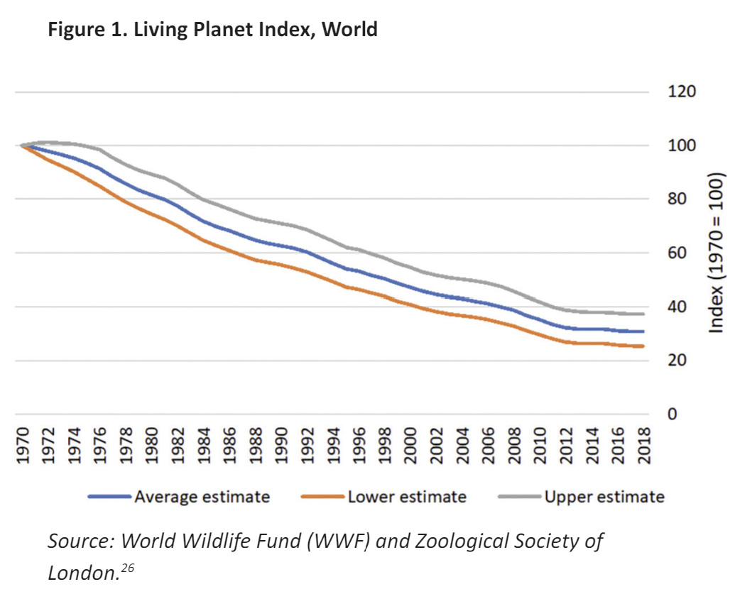
Australia has extensive federal and state environmental protection laws, which encompass a wide range of regulatory levers. Furthermore, our levers of environmental protection have been extended to biodiversity in recent years and biodiversity offset schemes have been established by various Australian governments.27
Broadly speaking, wealthier economies have better environmental outcomes, after experiencing worsening outcomes in the initial phase of economic development. This is a phenomenon known as the Environmental Kuznets Curve (EKC), although the evidence on the curve is “mixed” as Nobel laureate William Nordhaus has described it.28 There does appear to be an EKC for greenhouse gas emissions per unit of GDP, but there is EKC for particulate matter, which moves only in the downward direction as economic development increases.29 Incidentally, there is strong evidence that democracies have cleaner air, and Nordhaus concludes: “the evidence supports the pro-environment nature of democratic institutions.” This is an important lesson. One of the greatest environmental tragedies of the 20th century, the degradation of the Aral Sea in the Soviet Union, occurred on the watch of an authoritarian regime.30
Ultimately, the perceived link between economic growth and environmental degradation underpinning the degrowth view is misguided. As Treasury observed in its 1973 Economic Growth: Is it worth having? paper:
… the premise that increases in output of goods and services must necessarily be accompanied by corresponding increases in pollution is mistaken. Relationships between output and pollution can readily be changed if society has the will to do so. Such changes can make a far greater contribution to reducing pollution than measures designed to halt or slow down the rate of economic growth.31
Robert Solow made a similar point that same year, that excessive pollution and environmental degradation are by no means an unavoidable accompaniment to economic growth, but a result of “an important flaw in the price system.”32 In some cases, as was the case with, chlorofluorocarbons (CFCs) and other chemicals damaging the ozone layer, there is a clear low-cost response and the solution is straightforward — through the 1987 Montreal Protocol by which 197 countries agreed to phase out the chemicals.33 In other cases, measures such as corrective taxation or emissions-trading schemes can be implemented to address that flaw. Throttling the economy so it degrows would be the wrong way to go about it.
Certainly, wealthier countries are better placed to engage in conservation measures. A 2021 study of extinction risk published in the leading journal Diversity and Distributions found the higher GDP was in an area, the greater the risk to threatened species, measured by the Index of Threat (IoT), but it “found substantial variation in the congruence of IoTs with anthropogenic pressures for species of different kingdoms, life-forms, threat categories and regions”.34 This suggests that the relationship is not guaranteed, and a range of factors including better management and enforcement can play a role. Indeed, the researchers acknowledge that some outcomes are better in areas with higher GDP:
…countries with a high GDP have the resources to impose better biosecurity measures and to manage invasive animals. So, while economic development has resulted in increasing numbers of threatened species, it could also provide the financial resources required for biosecurity and conservation.35
Of course, there may be concerns about lower levels of environmental protection in emerging or developing economies. This is a complex issue beyond the scope of this paper. Economists would suggest that a lack of clearly defined property rights leading to the tragedy of the commons is often a problem. This is borne out by experience. For example, rainforest conservation efforts in Brazil have been hampered by “lawlessness”, as reported by The Economist. 36
Finally, in this section, we can quickly dispense with claims regarding resource depletion. Broadly speaking, higher prices encourage conservation of resources and new exploration. Resource depletion is a poor argument for degrowth. The notorious Simon-Ehrlich wager on commodity prices is well known, with Ehrlich, predicting higher commodity prices by the end of the 1980s, having lost the bet to economist Julian Simon.37 Ehrlich, the author of the Population Bomb, was also famous for forecasting collapsing global population as early as the late 20th century. Of course, the record has been of expanding population, having doubled from 4 billion in 1975 to more than 8 billion today. Furthermore, concerns about peak oil in the years prior to the financial crisis proved misplaced. Global oil production has continued to trend upwards since the peak oil hypothesis was advanced in the 2000s, with annual global output now more than 4 billion tonnes, compared to 3½ billion in the first decade of the century.38

It fails: has zero support, causing military crackdowns, populism and a return to capital which reverses growth’s gains locking in mass starvation.
Wolf 23, Chief Economics Commentator at the Financial Times, M.Phil., Economics, Oxford University, B.A., Economics, Oxford University (Martin Wolf, 2023, “Chapter 7: Renewing Capitalism,” in The Crisis of Democratic Capitalism, Penguin Press, University of Kansas Libraries, ILL)
Reform, Not Revolution
Some aspire to something far more dramatic than mere reform: they aspire to nothing less than anti-capitalist revolution. After two big economic crises— the transatlantic financial crisis and then COVID within just twelve years, followed by the shock of Russia’s war on Ukraine, not to mention high inequality, slowing growth, a rising tide of authoritarianism, and, above all, increasing concern over environmental constraints, this is hardly surprising. Some of these revolutionaries argue that capitalism is a cancer, economic growth must be halted, and human beings should embrace a preindustrial, even pre-agrarian, way of living. [4] Thus, Jason Hickel, an economic anthropologist, writes in Less Is More that “we need high-income countries to scale down excess energy and material use; we need a rapid transition to renewables; and we need to shift to a post-capitalist economy that’s focused on human well-being and ecological stability rather than on perpetual growth. But we also need more than this—we need a new way of thinking about our relationship with the living world.”[5] Hickel and people like him wish to overthrow our economic system. Yet no political party with such goals has the slightest chance of gaining power. The transformation he desires could only be implemented by a dictatorship, and a global dictatorship at that. No such regime is (happily) in prospect. This is at best unrealistic utopianism. At worst, it is yet another in a long succession of “progressive” calls for tyranny.
Even a true end to economic growth would not solve the problem. Suppose global economic growth did cease and emissions per unit of output continued to decline at the same rate as between 1990 and 2018—that is, at about 1.8 percent a year. Annual global emissions would still have fallen by only 40 percent by 2050. That would not solve the climate problem: it would just mean that it would go on getting worse more slowly. The only ways to achieve zero emissions are either to divorce output from emissions or to eliminate all output that depends on inputs of commercial energy. If the former were possible, neither an end to growth nor the far more radical alternative of eliminating all the increase in global output since the industrial revolution would be necessary. The latter is certainly politically impossible. But it is also morally unacceptable. It would require reversal of virtually all increase in economic welfare of the past two centuries, with devastating consequences for individual well-being and political and social stability.It is essential to grasp what the preindustrial world was like. Two hundred years ago, more than 80 percent of the world’s (then much smaller) population lived on the borders of survival. Most people were subsistence farmers. Undernourishment was widespread and starvation a permanent threat. Before COVID-19 the proportion of the world’s population in such desperate poverty had already fallen to below 10 percent—still far too high, yet a dramatic improvement from the situation of preindustrial humanity. What is more, nearly half of that decline in the proportion of those living in such destitution occurred in the golden age of globalization after 1980 (see figure 42).
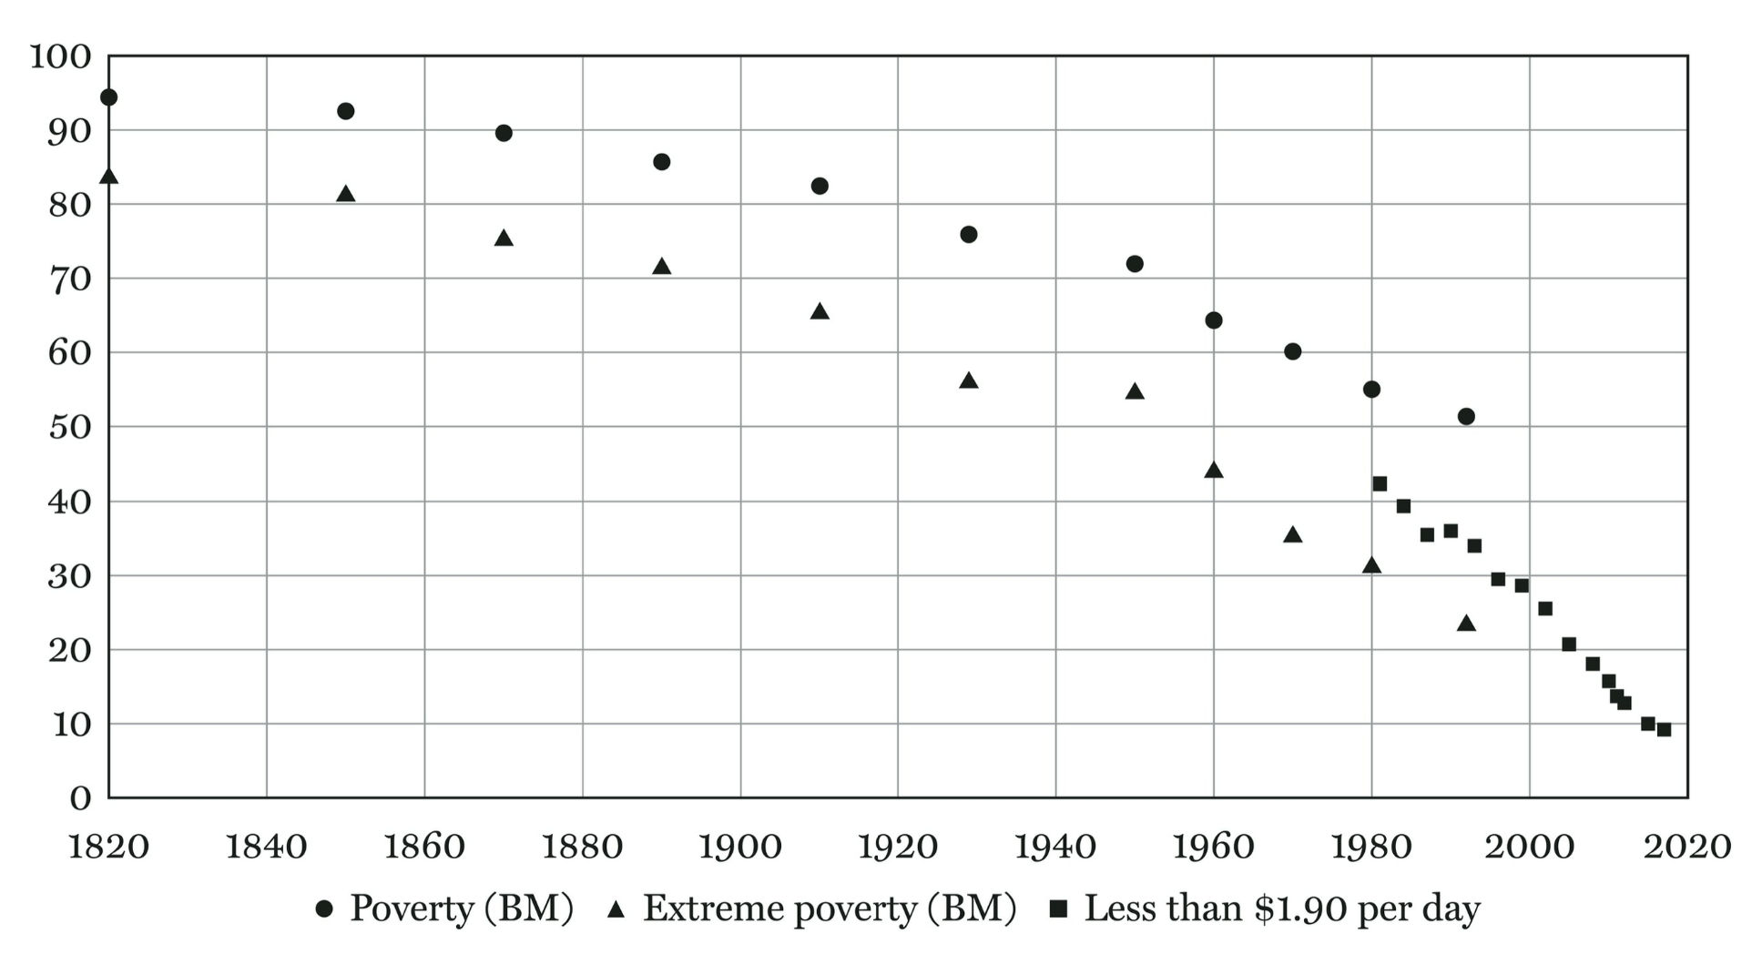
Over these two centuries, the proportion of the world’s population living in extreme destitution fell from 80 to 10 percent, despite a more than sixfold rise in the human population. That population explosion was also in significant measure due to rising life expectancy: average world life expectancy rose from around thirty years at birth in 1800 to forty-six in 1950, and then seventy-one in 2015, with much of this rising longevity due to falling child mortality. [6] Arguably, this transformation in life expectancy is the most profound improvement of the last two centuries, with revolutionary consequences for the opportunities for women, size of families, investments in education, and the aging of societies, but also for the value we place on human lives and many other valuable aspects of our societies. It is surely a profoundly welcome transformation. How many bewail the fact that children increasingly survive to adulthood? By historical standards, COVID-19 is even a very modest pandemic. The fact that it upset us so much shows how far we now take for granted our ability to control illness and postpone death. [7] Our ancestors took such disasters—indeed, far worse ones—for granted.
In sum, “de-growth”—let alone the far more radical alternative of actually reversing industrialization—is a utopian (or rather dystopian) illusion foisted upon us by people who are more interested in reversing thousands, or at least hundreds, of years of human history than in solving the problems we actually confront. [8] A practical and acceptable solution can come only from a technological transformation that eliminates emissions of greenhouse gases from the economy. [9] What is needed is not de-growth, but rather “de-emissioning” growth.
The value of a dynamic market economy lies not only in the prosperity it has created and the longer lives it has allowed us to live. It lies also in the sort of lives it allows people to lead. Markets allow people to use their imagination, skills, and efforts to better themselves, without approval from a higher authority. They need only find someone interested in paying for what they create. In this respect, markets are egalitarian. They do not have egalitarian outcomes, but the ability to engage in the market is not dependent on social status, though it does depend on inherited abilities and acquired resources. Anybody is allowed to try. Nobody appointed Elon Musk or Bill Gates to their positions in society. In countries with the rule of law and no, or limited, corruption, this opens huge opportunities. That, too, is a value worth cherishing and defending.
Furthermore, markets impart information. Market incentives will influence everybody in the market. The alternative is some form of top-down command and control. Quite apart from the coercion this would require, a central planner will never know all the possibilities, as people operating independently can. They can, above all, never know what is in everybody’s head. Even in the age of big data, markets exploit knowledge and adjust incentives in ways no other social mechanism does. Of course this does not mean markets are perfect. On the contrary, the strongest justification for markets is that they encourage independent trial and error in an environment of fundamental uncertainty. They are pluralist. If we enjoyed perfect information about the future, markets would be far less valuable, for we would know so much more about what needs to be done. If they are to work well, both economically and socially, markets need careful design and regulation and must not be dominated by a small number of oligarchs. But they remain an essential social instrument.
Moreover, as Edmund Burke argued in his Reflections on the Revolution in France, not only is it impossible to build a new society from first principles, but it is also inhuman even to try. [10] We must always build on what we have and know. The Russian Revolution turned out to be a seventy-four-year journey from a highly unequal and predatory tsarist state, though one with at least some hope of reform, to an even more unequal and predatory state, with even smaller hope of democratic reform. On the way, tens of millions of people were killed in the Soviet Union and tens of millions more, under the same ideology, worldwide. [11] Moreover, so utterly did the utopians smash the possibility of liberating reform that when the chance for that was offered once again, in the 1990s, it was lost. Utopianism is absolutely destructive.
A particularly relevant part of that painful history was the intended creation of “New Communist Man.” According to Leon Trotsky, “Man will make it his purpose to master his own feelings, to raise his instincts to the heights of consciousness, to make them transparent, to extend the wires of his will into hidden recesses, and thereby to raise himself to a new plane, to create a higher biologic type, or, if you please, a superman.”[12] In practice, the new communist man was an amoral predator. The transformation of actual human beings, with all their faults and virtues, into “ecological” man (and woman) is equally implausible. We must do our best with humans as they are—with their mixture of greed and selflessness. The idea of the perfectly ecological human is quite as much a delusion as Trotsky’s communist superman. Just consider the mass extinctions that followed humanity’s first arrival in Eurasia and the Americas back in prehistoric times. [13]

1AR

Decoupling.
Kounis et al. ’23 — Nick Kounis, Head of Financial Markets & Sustainability Research, ABN AMRO Bank, M.Sc., Economics & Finance, Durham University; Casper Burgering, Senior Economist, ABN AMRO, B.A., Economics, Vrije University, Amsterdam; Sonia Renoult, Rates Strategist, ABN AMRO; February 26, 2023; “The Decoupling of Emissions From Economic Growth”; ABN AMRO Economics Growth, SustainaWeekly; https://www.abnamro.com/research/en/our-research/sustainaweekly-the-decoupling-of-emissions-and-economic-growth
The difference in the degree of decoupling and the stage of economic development also emerges from our analysis. For example, a clear difference can be seen between different regions, such as Asia, South America (emerging economies) on the one hand, and North America and the eurozone (developed economies) on the other. China has indicated that peak CO2 emissions will be reached in 2030. India's peak emissions are also around that year. Both countries are still developing and have high economic growth numbers, which is associated with high and increasing greenhouse gas emissions. However, the figures also show that Asia is often also in the phase of weak decoupling. In this case, both GDP and CO2 emissions are growing, but the GDP growth rate is at least 20% higher than the growth rate of CO2 emissions. Most countries in South America are also emerging economically and, as a result, an expansion of negative decoupling is still frequent. However, according to a November 2022 OECD report, South America is in a ‘good position to begin an effective green transition and make faster progress toward its economic, social and environmental goals’. The region ranks relatively well on many sustainability indicators. For example, per capita emissions are lower than other regions with similar levels of development, and its energy mix is already greener today. Renewable energy sources represent 33% of its total energy supply, compared to 13% worldwide, according to the OECD. Many countries in Europe have already decoupled CO2 emissions from GDP growth. The United Kingdom, France, Germany, the Netherlands, Sweden, Finland, Denmark, Italy, the Czech Republic and Romania are some examples where this process is observable. Outside Europe, the US is the largest country that has experienced several consecutive years in which economic growth has been largely decoupled from CO2 emissions growth.
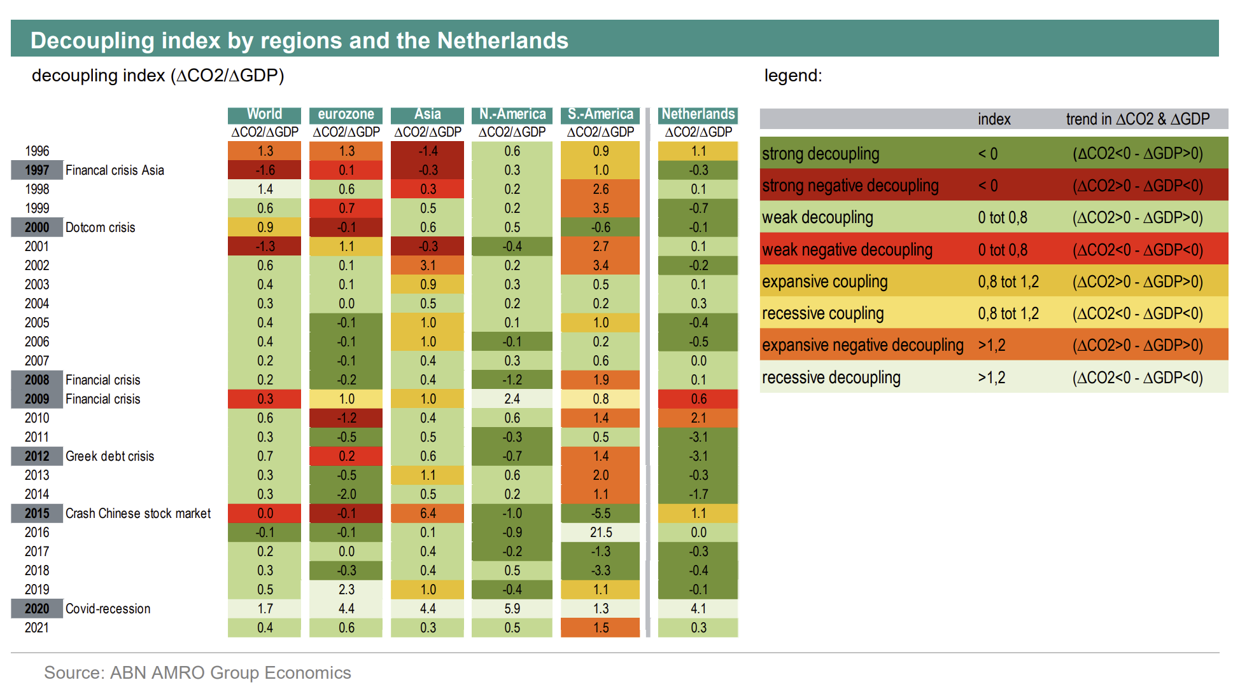
The table above shows that ‘strong negative decoupling’ (the darkest red areas) is more something of the past and, for now, only occurs during major economic shocks. In any case, this extreme situation has not been observed at the regional level since 2016. Of course, this situation can occur at the country level. In any case, it is clearly visible from the table that during economic shocks or other external dismay (like a pandemic), the trend in the linkage between CO2 emissions and GDP is disturbed considerably. Around economic shocks the negative decoupling often increases, varying between strong, weak and expanding. We see this occurring during the 1997 Asian Financial Crisis, the 2000 Dotcom Crisis, the 2008-2009 Financial Crisis, and the milder crises in 2012 and 2016. In the Covid year 2020, it was especially recessive decoupling across all regions. Then both GDP and CO2 emissions declined firmly, but CO2 emissions declined much more sharply. The world was in lockdown, and this resulted in a strong decline in the movement of people and goods, causing CO2 emissions to fall more quickly. Decoupling in the Netherlands The decoupling of GDP growth and CO2 emissions growth is partly seen in the Netherlands as well, although here the variation in outcomes are sometimes much larger. In the left graph below, the dots are scattered across almost all areas of the matrix, except in the 'strong negative decoupling' area. The outliers in the Netherlands in the relationship between growth in CO2 emissions and GDP growth are particularly noticeable in the 1970s, but partly also in the 1980s. <<FIGURES OMITTED>> The general trend seen for the Netherlands run from weak decoupling to strong decoupling. However, in terms of emission reduction since 1990, the Netherlands compares worse than other EU countries. Compared to 1990, total greenhouse gas emissions in the Netherlands have fallen less than the EU average and almost all major economies in the eurozone. This underperformance has been linked to relatively slow progress towards renewables, and to some extent also because of large reliance on gas in the Netherlands. But over the past decade, the Netherlands has stepped up and performed better than the EU average. In many sectors, CO2 emissions have declined since 1995, while their value added has grown. These are all dark green dots in the right-hand figure above. Almost two-thirds of the sectors are plotted there, with mostly industrial sectors, but also energy supply, retail and ICT-services sector. About eight sectors show a weak decoupling over time, with GDP growth exceeding growth in CO2 emissions. Finally, two sectors show both a decline in value added and emissions, where the decline in CO2 emissions has been sharper. Maintaining economic growth is important for further sustainability This analysis shows that reducing carbon emissions need not necessarily be accompanied by a decrease in economic growth. Decarbonization of an economy can be well achieved by improving energy efficiency and reducing carbon intensity. To this end, companies in sectors have various measures and techniques available to decarbonise, with many low-hanging fruit (see here). However, there is no one standard success formula, no common climate policy or other typical solution that leads to stronger decoupling. Some countries have an ambitious and strict climate policies, which accelerates decoupling, while other countries have managed to increase both private and public investment sharply in renewable energy. In any case, our analysis shows that limiting CO2 emissions can go well hand-in-hand with maintaining economic growth. The data show that many countries have achieved a strong decoupling, with CO2 emissions decreasing and the economy growing. The results thus offer a strong argument that economic growth is an important and perhaps crucial condition for further sustainable development. However, it does not take away from the fact that a strong rationalization of our consumption behaviour for further sustainable development is eminently a good way to contribute to our goal of a stronger reduction of CO2 emissions towards 2030 and 2050.

2AR

